**Methods**

The purpose of this “toy example” is to illustrate the potential for approximating equilibrium quantities within a spatially-structured assessment model. [Detail here on how analytical solution impossible].

*Basic Structure*

To illustrate the various approaches to calculating spatial reference points described above, we constructed a simple age-structured model with three spatial areas where a survival equation links age classes, and gear-selectivity is specified for three fleets, each targeting a single area (similar to Sampson, 2014). The basic model does not consider growth and instead specifies an empirical weight-at-age for each area. Ages are modelled from 0 (recruits) to 20+. Mortality is fixed for all areas at 0.15. Selectivity-at-age is dome-shaped (Figure 1).  Movement is governed by a probability transition matrix between areas at each age, . The matrix specifies unidirectional movement from areas 1 and 2 to area 3 at varying proportions for fish below age 6, after which fish remain in their respective area (Figure 2).The numbers-at-age for each sex in each area are generated by the following:

Where is a vector of length i (number of areas) indicating the distribution of age-0 recruits to

each area; and

is the area- and age-specific fleet selectivity; and

F is the fishing mortality rate; and

is a user-defined reference recruitment level

Spawning biomass given F is obtained by multiplying female numbers-at-age by the expected weight at age and fecundity at age. This can be left as an area-specific value or summed to become total spawning biomass, .

*Recruitment*

Equilibrium calculations assume a Beverton-Holt stock recruitment relationship with a shared value for steepness (h). The general form of this relationship is:

(2a)

(2b)

Where is the equilibrium spawning biomass;

SB0 is the unfished spawning biomass obtained by setting F to 0 in Equation 1;

*h* or steepness (the expected proportion of unfished recruitment at 20% unfished

spawning biomass) is 0.5; and

is unfished recruitment, set to 500.

*Equilibrium Calculations: Two Approaches*

Here we present two alternative methods for calculating equilibrium recruitment, biomass and yield under a given value of *F* (which is applied to all three areas). The first approach, referred to here as “current”, reflects the extant method used in Stock Synthesis when the user has specified a multi-area model. [More detail on current approach here]. The second approach, labeled “proposed”, aims to approximate the equilibrium conditions of a spatial model.

The essential difference between the two approaches is that the “proposed” approach considers the conditions within individual areas, and re-weights the distribution of age-0 recruits based on the ratio of equilibrium biomasses among areas under a given *F*. In practice, the proposed approach proceeds as follows:

1. Distribute to areas according to a nominal recruitment distribution,
2. Iterating among areas within ages, calculate the survivors-at-age, and mix them according to the movement matrix (Equation 1). Until this point, both approaches are identical.
3. Note both the area-specific and total spawning biomass and yield.
4. Calculate spawning-biomass-per-recruit and yield-per-recruit for each area, using and , i.e.

;

1. Use Equation 2 to calculate the expected recruitment from each area, using the area-specific unfished biomass and ; unfished recruitment is given by . Multiply this by the quantities found in Step 4 to determine the expected spawning biomass and yield by area.
2. **Maia unclear about this step, not currently implemented:** The new global recruitment level, Rreftilde, is the sum of equilibrium recruitment from each area.

OR Use Equation 2b to calculate expected equilibrium biomass from each area, using the area-specific unfished biomass and ; unfished recruitment is given by . The new global recruitment level, Rreftilde, is found by summing equilibrium biomass across areas and using these values in Equation 2a.

1. Adjust by the ratio
2. Repeat steps 1-5 once, using in lieu of .

*Results*

TBD

**Tables**

|  |  |  |  |
| --- | --- | --- | --- |
| **Symbol** | **Description** | **Current Approach** | **Proposed Approach** |
|  | Distribution of age-0 recruits among areas | Area 1 = 0.5  Area 2 = 0.3  Area 3 = 0.2 | Adjusted based on areal ratios of equilibrium B |
| h | expected proportion of unfished recruitment at 20% unfished spawning biomass | 0.5 | unchanged |
|  | Unfished recruitment | 500 (global) | unchanged |
|  | Reference recruitment | 100 (global) | unchanged |

Table 1. Input parameter values for both the current and proposed approaches.

**Figures**

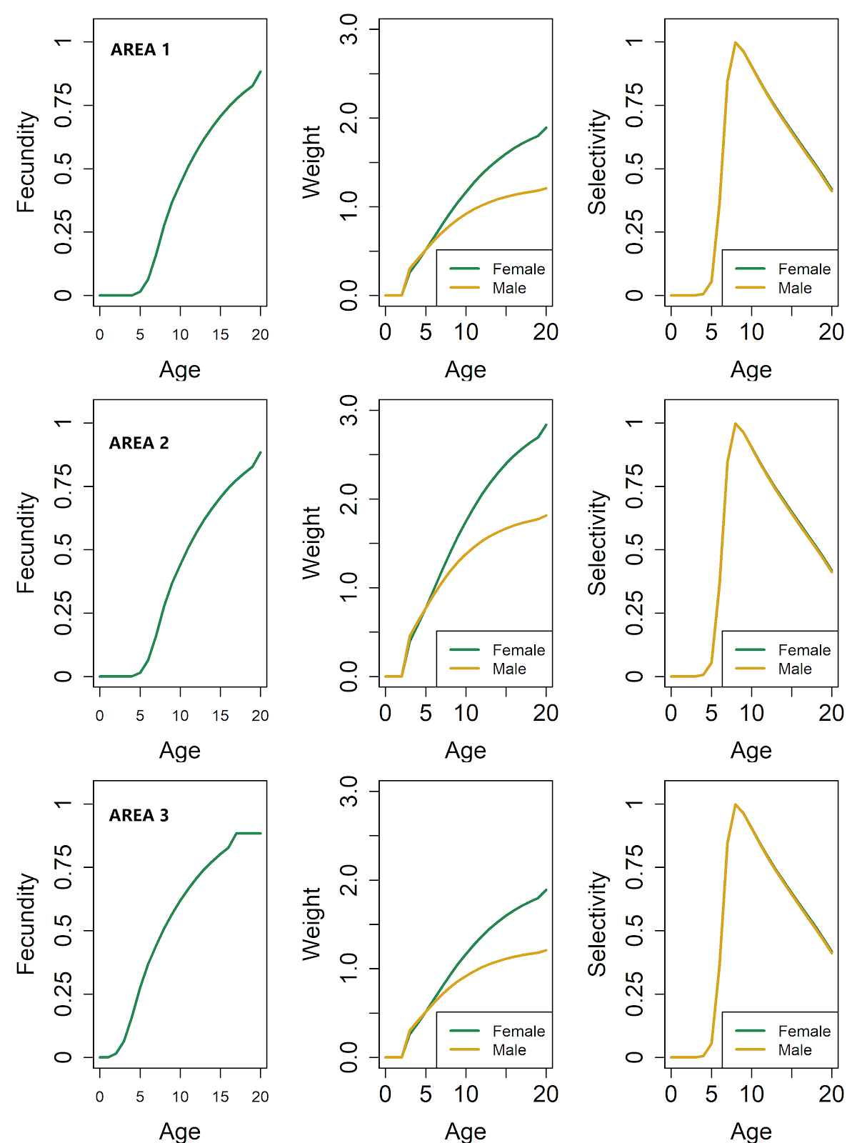

Figure 1. Input female fecundity-at-age (leftmost column), weight-at-age (central column), and fishery gear selectivity (rightmost column) for females (green lines) and males (gold lines) in each of three spatial areas (rows).

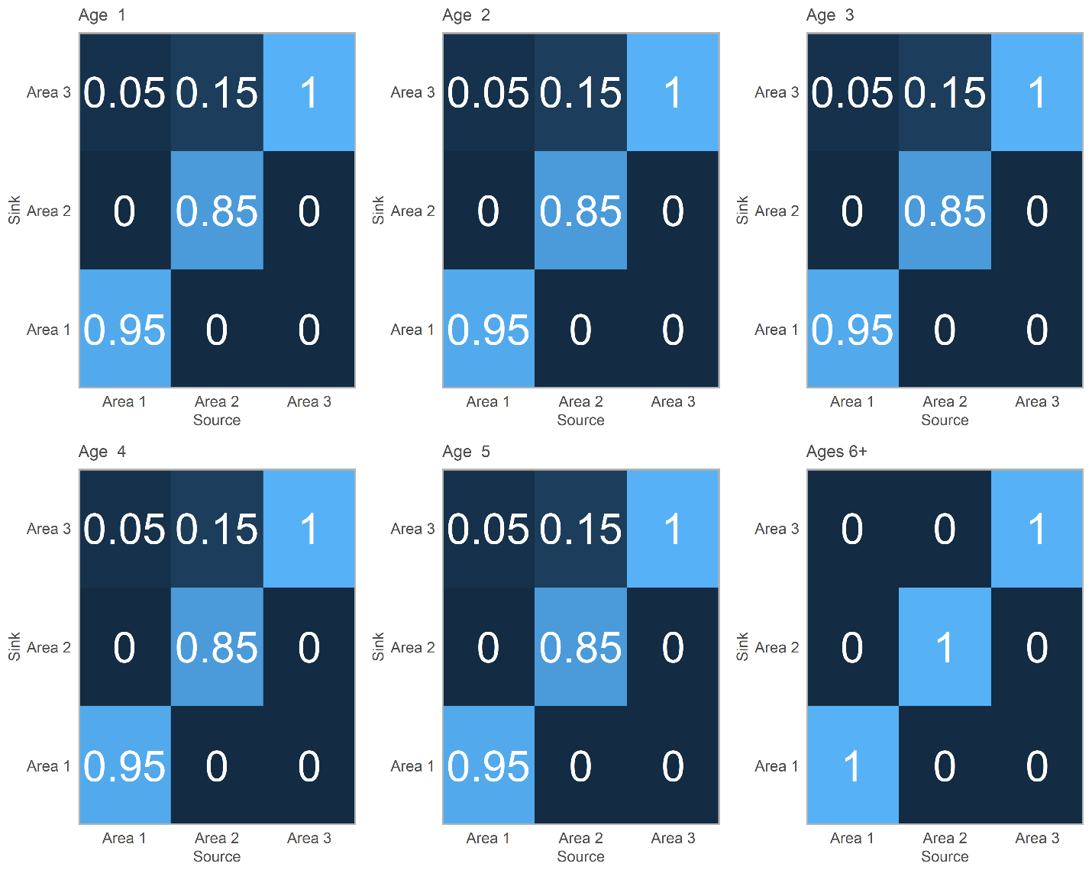

Figure 2. Input probability transition matrices among areas by age. Movement is unidirectional from areas 1 and 2 to area 3 for fish under age 6 and ceases thereafter. Lighter colors indicate higher movement probabilities; value within cell indicates the probability of moving from the source area to the sink area.

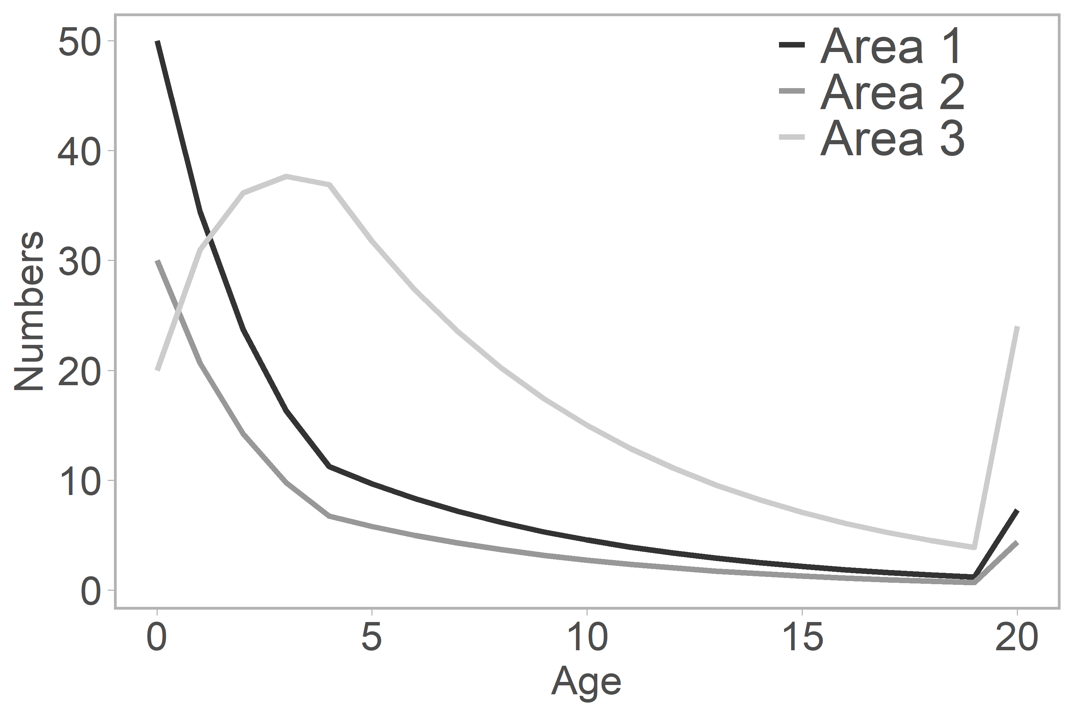

Figure 3. Unfished total numbers-at-age in areas. The unidirectional movement dynamic acts as a subsidy of individuals to Area 3.

Figure 4. Comparison of yield curves between “current” (green lines) and “proposed” (gold lines) approaches for calculating equilibrium conditions.

Figure 5. Relationship between yield, biomass and F within areas. The vertical black line in the central panel indicates the point at which Area-2 biomass is zero, and corresponds with the maximum yield obtained by Area 3.